***Lab4 – Working with Model***

*Follow the steps:*

*File > New > Project > Select Web > ASP.NET Web Application > Name it as ModelDemo > Click OK Button*

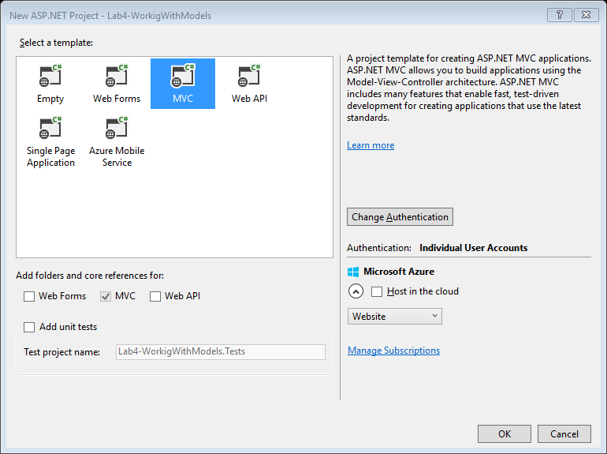

*From the window select MVC > Click on Change Authentication*

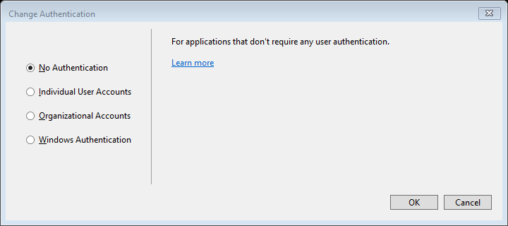

*Select No Authetication > Click OK Button*

*Click O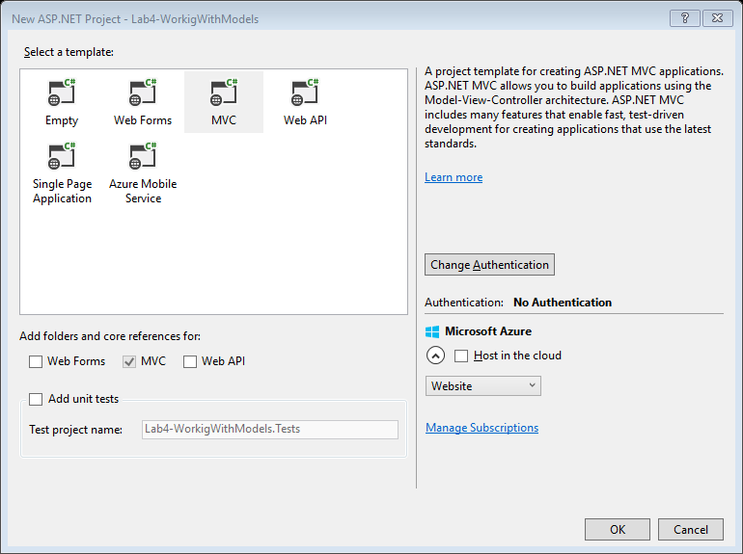k Button. Following Solution will be created.*

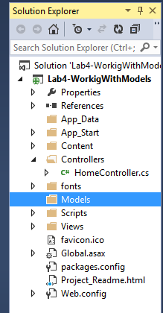

*Right click on the Solution and Add New Folder > Name it as Images > Right Click on the Images folder > Add > Existing Item > Select an image which you want to use as logo*

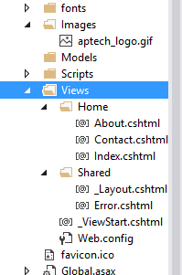

*Goto _Layout.cshtml underView/Shared Folder:*

*Change:*

**

*To:*

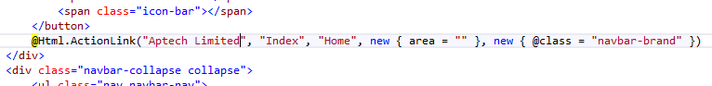

*Goto Index.cshtml under View/Home Folder.*

*Make the following Code Changes:*

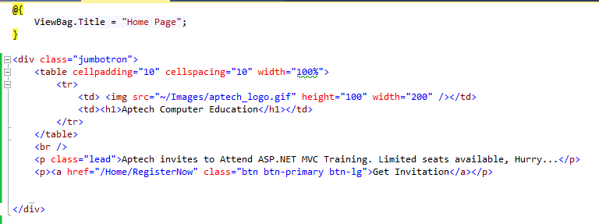

*The web page will look like this:*

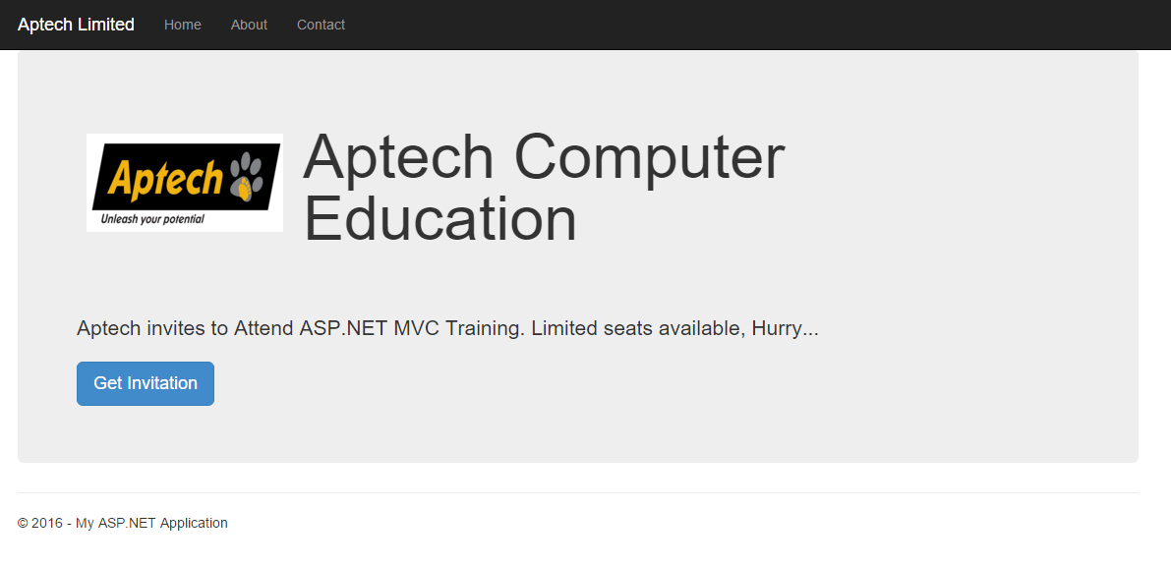

*The Code can be made better by using HTML Helper Methods. Add the following Code below the <p> tag:*

**

*The web page will look like this:*

**

*Right click on Models Folder > Add > Class > Name the class as GuestResponse.cs and add the following code snippet.*

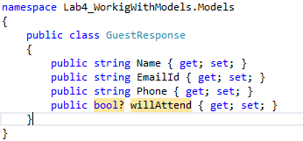

*Build the solution and Goto HomeController and add the following code snippet:*

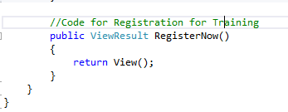

*Creating a Strong typed view > Right click on the RegisterNow action method > Add View:*

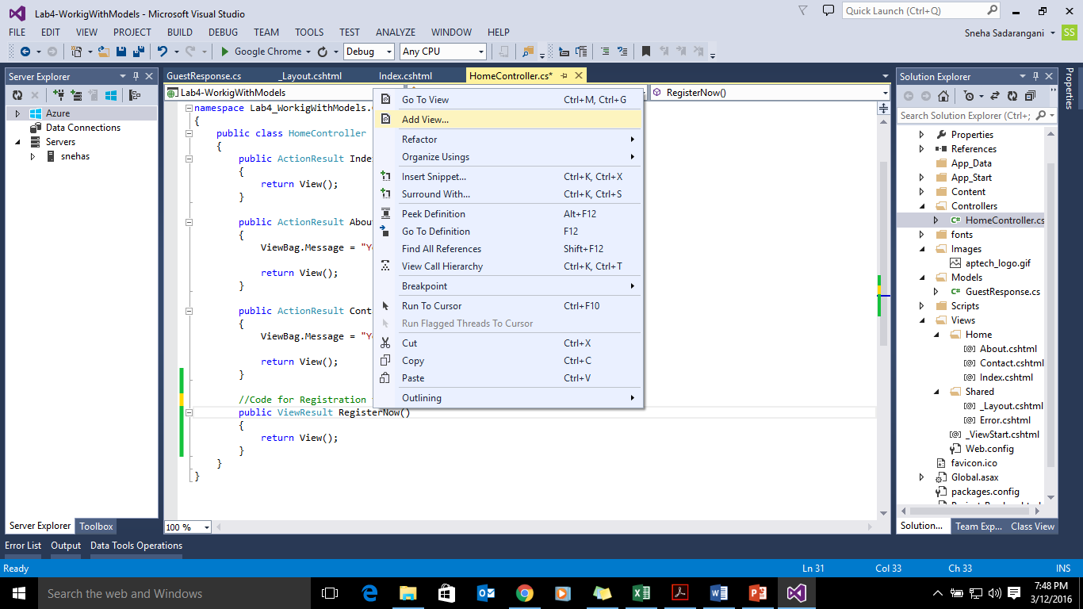

*Perform the following as Shown in the image and Click on Add:*

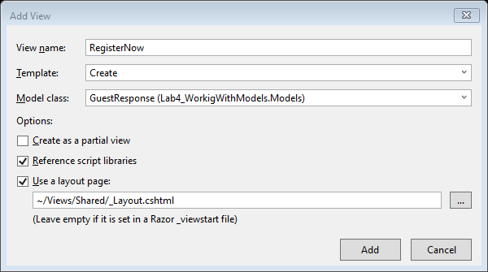

*After Execution the web page will look as follows:*

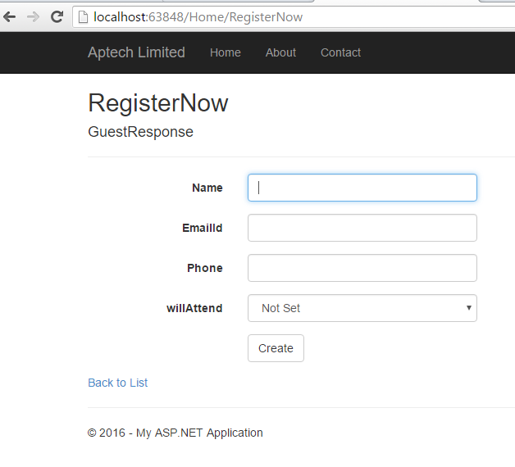

*We need to change the web page as follows:*

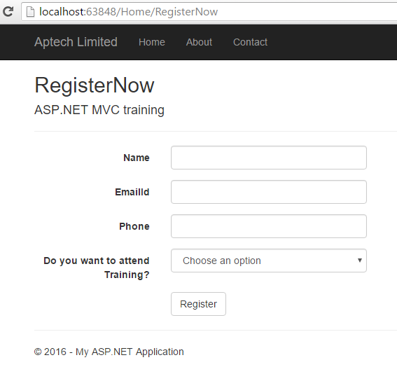

*You need to make the following changes in the RegisterNow.cshtml*

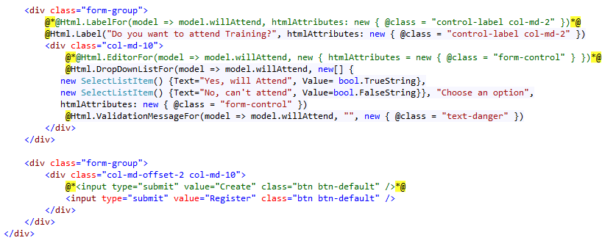

*Now writing the event on the Register button click. In MVC there are no events so action method of the same name will be written.*

*Following needs to be done:*

*Add namespace and following code:*

**

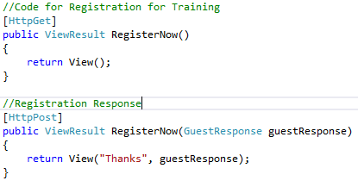

*Right click on RegisterNow action method with[HttpPost] action selector > Add View > Make the necessary changes as in image > Click Add button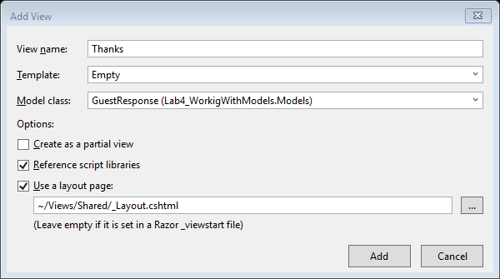*

*Now we will write the code for sending an email through Razor Syntax:*

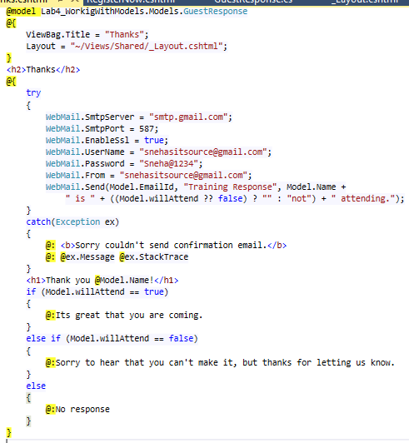

*On Execution:*

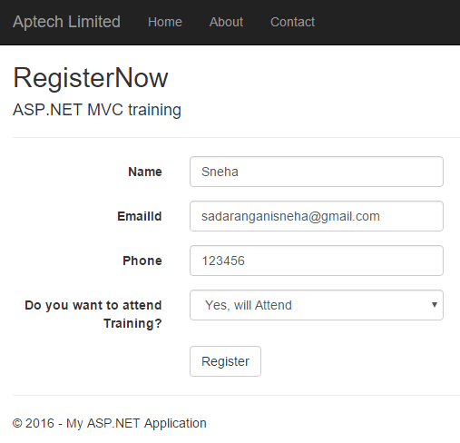

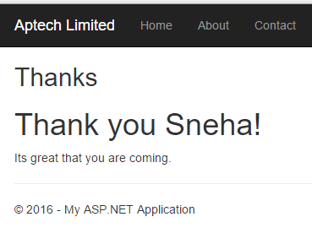

*Changing the ActionName:*

*Add the following code snippet in HomeController*

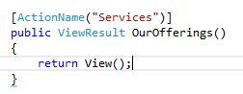

*Add View named Services.cshtml*

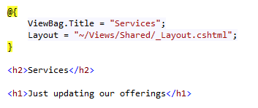

*After execution:*

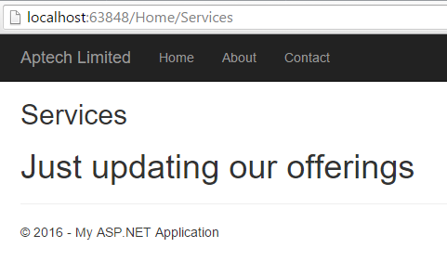

*NonAction:*

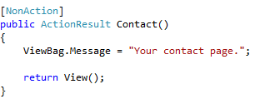

*After Execution:*

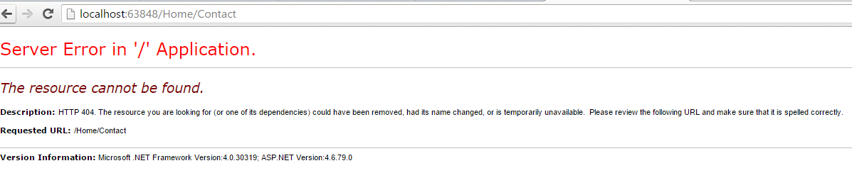

*Validations have not been done. Now let’s work with Validate Data:*

*Validation can be implemented in the Model. Following the code:*

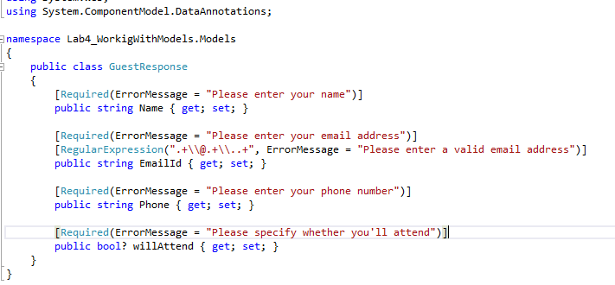

*After Execution*

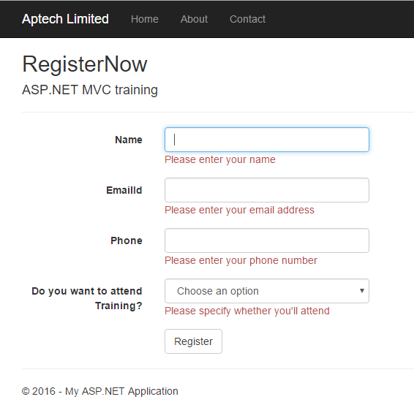

*Validating the Model.*

*Modify the following code in HomeController:*

